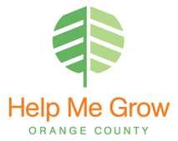

Thank you for your interest in the Help Me Grow Listserve Announcements.

The Listserve Announcement is organized by date. Events that have multiple dates will be posted by the month they take place. The Listserve goes out on Thursdays to all subscribers.

Guidelines for the Help Me Grow Announcement are as follows:

- Send information either in the body of an email, in a Word document or on the template provided below. Please make sure to include the following:
  - date
  - location
  - contact information
  - a short description (2-3 sentences) of the event, workshop or training (events must be for children or parents)
  - PDF flyer with detailed information (if needed) Limit the size of the attachments to 10 mega bytes.
- Agency newsletters, job postings or advertisement for ongoing services cannot be included in the Listserve.

IMPORTANT: Listserve requests must be sent to the appropriate liaison by Friday 5pm to be included in the following week's announcement.
- Deanna Parga – Region I
- Claudia Estrada – Region II
- TBD – Region III
- Cynthia Rodriguez- Region IV
- Announcements in multiple cities or out of county can be sent to any of the liaisons.

Our goal is to share events effectively and efficiently with our community partners.

We thank you for your cooperation.

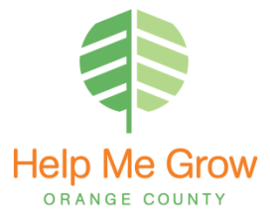

Name of Event:
Description:
Date:
Location:
Contact information:
**Be sure to submit any flyers you’d like included

